Project Design Phase-II Technology Stack (Architecture & Stack)

Date Team ID

Project Name Maximum Marks

15 October 2022 PNT2022TMID13439

Project – Smart Farmer-IoT enabled smart farming application.

4 Marks

**Technical Architecture:**

The Deliverable shall include the architectural diagram as below and the information as per the table1 & table 2

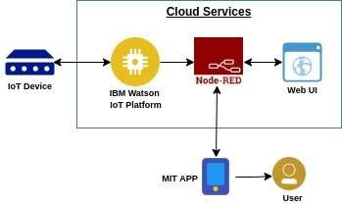

**Table-1 : Components & Technologies:**

**S.No Component Description Technology**

1. User Interface
2. Application Logic-1

How user interacts with application e.g. Web UI, Mobile App, Chatbot etc.

Logic for a process in the application

MIT app

Node red/IBM Watson/MIT app

1. Application Logic-2

Logic for a process in the application

Node red/IBM Watson/MIT app

1. Application Logic-3

Logic for a process in the application

Node red/IBM Watson/MIT app

1. Database

Data Type, Configurations etc.

MySQL, NoSQL, etc.

1. Cloud Database

Database Service on Cloud

IBM cloud.

1. Temperature sensor Monitors the temperature of the crop
2. Humidity sensor Monitors the humidity
3. Soil moisture sensor (Tensiometers) Monitors the soil temperature
4. 10.

Weather sensor

Monitors the weather .

11. Solar panel

.

12. RTC module

Date and time configuration

13. Relay

To get the soil moisture data

**S.No Characteristics**

**Description**

**Technology**

1.

2.

Open-Source Frameworks

Scalable Architecture

MIT app,Node-Red

Drone technology, pesticide monitoring ,Mineral identification in soil

Software

Hardware

**Table-2: Application Characteristics:**